**CSA1086 - Software Engineering**

GitHub Collaboration

1. Fork a repository from another person

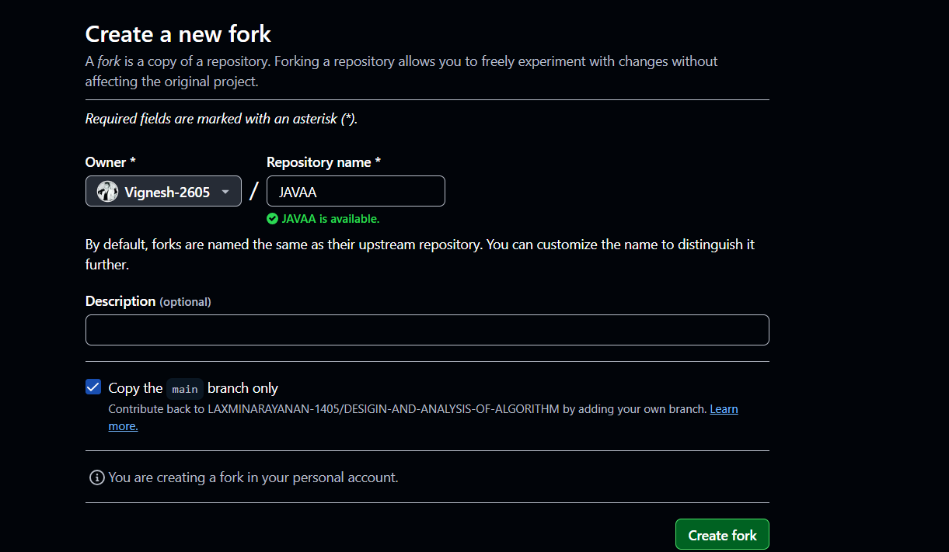

1. Clone the forked repository into the local computer

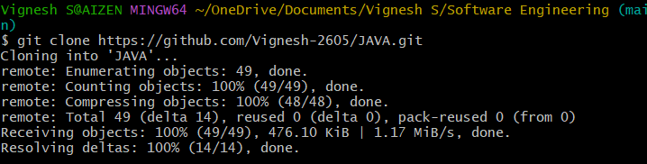

1. Move into the cloned repo folder



1. Create a new branch



1. Add the file and commit it into the branch

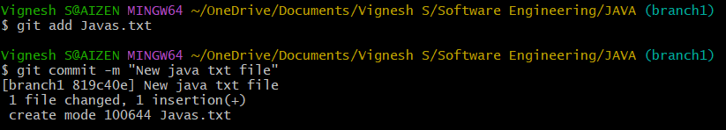

1. Push the branch into the main and create a pull request

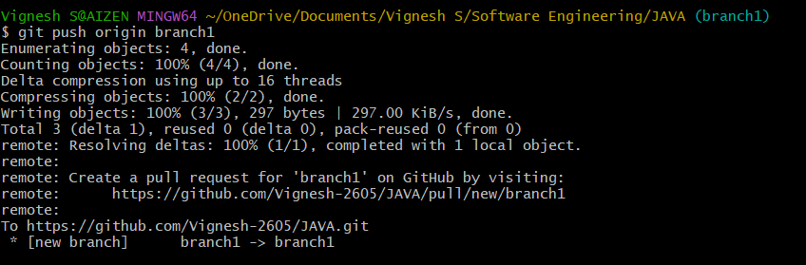

1. Submit the pull request and and ask the other person to accept and merge it

